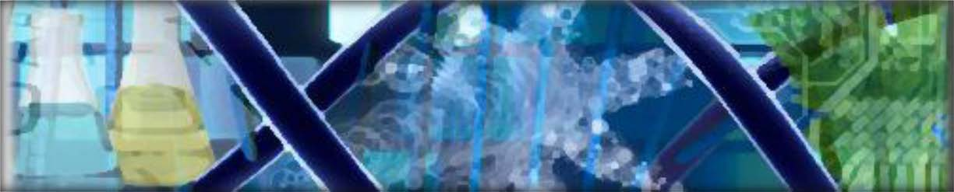

Introduction to Biotechnology-Student Resources
For Podcast 1.1 Introduction to Biotechnology
I. Define Biotechnology.

II. Biotechnology dates back to the beginning of civilization. Briefly describe some historical applications of biotechnology.
a. Fermentation

b. Selective Breeding

c. Mendel’s Work in Genetics

d. Vaccinations

e. Antibiotics

f. Genetic Engineering

III. Relating Biotechnology to Current World Issues
a. List fields of study with biotechnology applications.

Take Away Questions
1. Pick an example of a biotechnology application, and describe how it has affected your everyday life.

2. There are many websites that will keep you abreast of current advancements in biotechnology. Find an Internet site address that ends with .edu, .gov, or .org and offers the latest news and current events in science. Choose one article that is of interest to you and print it out. Highlight the main sentence in each paragraph. Place and asterisk (*) by three items in the article that you think are most interesting and important.

3. Biotechnology has a rich history of many important discoveries. Go to http://www.accessexcellence.org/RC/AB/BC/ and look through the timelines and classical biotech discoveries. Generate your own timeline with the five discoveries you think were most influential.

